Time Marches On
Heber Valley Quilters
2011 Block of the Month

July--Devil's Claw Block
In the very beginning of the Civil War, prisoners of war were exchanged right on the battlefield, a private for a private, a sergeant for a sergeant and a captain for a captain. In 1862 this system broke down and caused the creation of large holding pens for prisoners in both the North and South. Andersonville, in southwest Georgia, is by far the most well known of the Civil War prisons. Elmira Prison in New York was the Union version of Andersonville. Andersonville was built to accommodate up to 10,000 captured soldiers, but was jammed with over 32,000, almost all enlisted men. The open-air stockade, enclosed by 20 foot-high log walls, grew to 26 acres, but remained horribly overcrowded and conditions became more and more intolerable. During the summer months, more than 100 prisoners died every day. The North had learned of the camp's appalling conditions well before the emaciated survivors were released in 1865, and outraged citizens urged retribution on Southern prisoners of war. That was hardly necessary: the Union had its own wretched prison camps, including Elmira, New York, a 40-acre camp, where the death rate approached Andersonville's, even though the North was far better equipped to cope with captured soldiers. Andersonville's mass graves were replaced by a national cemetery, which is today still used as a burial ground for American veterans.
In the waning days of the American Civil War, when the Confederacy was struggling to stay alive, prison camps for Union soldiers were filled to capacity with starving men. A renegade officer of the Confederacy took more than a thousand Union soldiers on a long trek to the American west, what would become Colorado, into a deep canyon, Devil’s Claw Canyon, where they were held like slaves. Here they mined silver in a hidden mine, with the proceeds going back eastward to support the efforts of the Confederate States of America in purchasing weapons, clothing, ammunition and food.
The quilt block pattern called Devil’s Claw is a traditional block design from the mid 1800s and represents another portion of our Time Marches on Quilt for the civil war era. This traditional pattern has been used by quilters for nearly 150 years. We use this block to honor a traditional pattern, but also in honor of all the American prisoners of war throughout the years the United States has been a nation. This block is dedicated to our POWs.

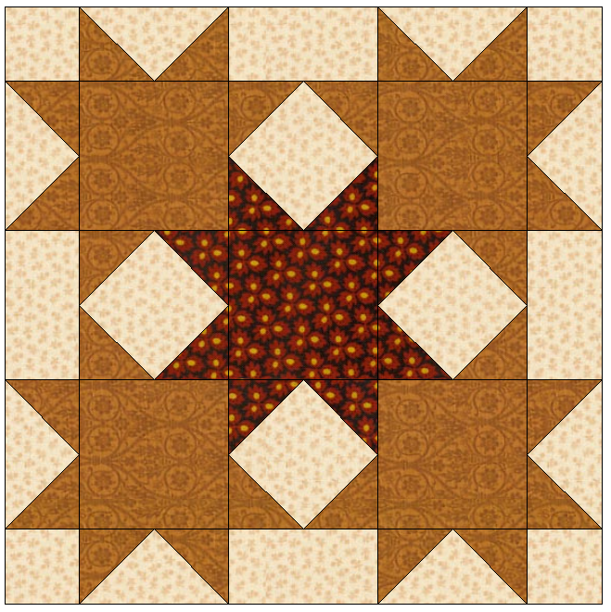
Make 1 – 12” finished (12 ½” unfinished) size block.

Cutting
Fabric A (gold)—4 – 3 ½” squares, 12 – 2 3/8” squares
Fabric B (brown center)—1 – 3 ½” square, 4 – 2 3/8” squares
Background fabric—4 – 2 5/8” squares, 2 – 4 ¼” squares,
Diagram 1
4 – 2” squares, 4 – 2” x 3 ½” rectangles

Block Construction
- Draw a diagonal line, corner to corner, on the wrong side of 4 Fabric A (gold) 2 3/8” squares.
- Position one Fabric A 2 3/8” square, right sides together, with one background 4 ¼” square. Drawn line should go from corner to center of large square. See diagram 1. Add a second 2 3/8” square to opposite corner. Drawn lines should line up. See diagram 2. Carefully pin both squares in place. Stitch a ¼” seam on each side of drawn line. Cut on drawn line. Press seam toward background triangles.
Diagram 2
- Position one Fabric A 2 3/8” square, right sides together, in the empty corner of background triangle. Drawn line should go from corner to center just as before. Stitch a ¼” seam on each side of drawn line. Cut on drawn line. Press seam toward background triangle. Repeat for remaining piece from step 2. Yields 4 flying geese blocks measuring 1 ½” x 3” finished (2” x 3 ½” unfinished.)
Diagram 3
- Repeat steps 1-3 once with 4 gold 2 3/8” squares and background 4 ¼” square to yield 8 flying geese blocks.
- Using 1 Fabric A (gold) 2 3/8” squares and 1 Fabric B (brown) 2 3/8” squares, cut both squares in half diagonally corner to corner to yield 4 triangles. You will be working with a bias edge so handle with care.
Diagram 4
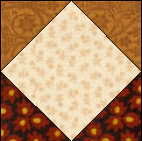
- Position 1 Fabric A triangle, right sides together, with one background 2 5/8” square. Line up along one side of square with corners of triangle hanging over the edges of the square evenly. The point of the triangle should be towards the center of the square. See diagram 3. Stitch using a ¼” seam. Press toward Fabric A.
- Position 1 Fabric A triangle, right sides together, on next side of square as in diagram 4. Added triangle will extend past previously added triangle. Stitch. Press toward Fabric A.
- Repeat steps 6 and 7 with 2 Fabric B triangles on remaining 2 sides of background square. Refer to picture 1 for placement.
Picture 1
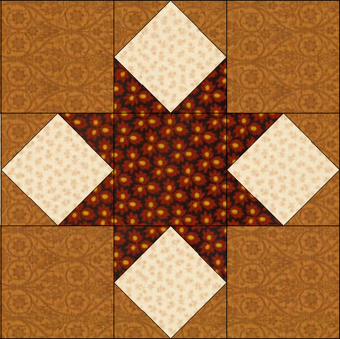
- Repeat steps 5 to 8 – 3 times to yield 4 – 3” finished (3 ½” unfinished) size units.
- Using the units finished in step 9 and 4 Fabric A 3 ½” squares and 1 Fabric B 3 ½” square, lay out pieces like a 9 patch block. Refer to picture 2 for placement. Stitch together as you would a 9 patch block. Press. This becomes the center of the block and measures 9” finished (9 ½” unfinished.)
Picture 2
- Using 2 flying geese blocks from step 4 and 1 background 2” x 3 ½” rectangle, layout pieces end to end in a strip with the background rectangle between the flying geese. Stitch together and press. Refer to picture of block as needed.
- Repeat step 11 to yield 2 strips measuring 1 ½” x 9” finished (2” x 9 ½” unfinished.)
- Stitch one strip to left side of center of block. Press. Stitch remaining strip to right side of center of block. Press.
- Repeat step 11 to yield 2 more strips. Stitch 1 background 2” square to each end of each strip. Press. New strip measures 1 ½” x 12” finished (2” x 12 ½” unfinished.)
- Stitch one strip to top of center of block. Press. Stitch remaining strip to bottom of block. Press.

